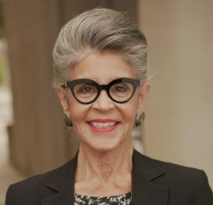
Mercedes Barajas-Tondre
Independent Consultant: Small Business/Non-Profit Sectors
Mercedes is a Los Angeles based Independent Consultant who brings a lifetime commitment to community and cultural diversity, more than 40 years of experience in marketing and communications, and expertise in small business development, entrepreneurial training, brand marketing, strategic planning, and project and budget management, focused on helping create equitable opportunities and resources for women, people of color, and underserved communities.

Engaged on a project basis, Mercedes’ approach to the development of compelling proposals, winning grants, culturally conscious strategic planning, and inclusive project management, is informed by deep collaboration with her clients and their staff, and an abiding passion for the shared goal of serving marginalized individuals and communities.

She also serves as the Co-Chair of the Vincent Price Museum Foundation, a non-profit organization created to support the Vincent Price Art Museum (VPAM), located on the campus of East Los Angeles College. VPAM is the only major museum located on a community college campus – with the mission of giving voice to artists of color.

In 2016, Mercedes co-founded OmniWorks Economic Development, an organization dedicated to fostering women, minority, LGBTQ, veteran, and formerly incarcerated entrepreneurs through business and emotional intelligence training, serving as its Executive Director until 2021.

Before joining OmniWorks Mercedes served as the Director of Corporate Partnerships at The Performing Arts Center of Los Angeles County and prior to that at the Autry Museum of the American West.

Prior to that Mercedes built a successful 40+ year career in marketing and advertising focused on theatrical and home entertainment clients and non-profit arts organizations.

As a Latina raised in the San Francisco Bay Area, Mercedes’ world view evolved as a result of the vibrant, diverse, arts-rich and social activism of the place and time.

