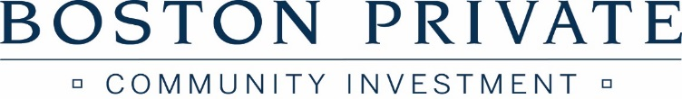

INVITES YOU TO ATTEND A
“COMMUNITY INVESTMENT SERIES” WEBINAR
Wednesday August 26, 2020

11:00 AM to 1 PM
Please RSVP for Webinar Link

Reopening the Workplace – Best Practices for California Nonprofit and Small Business Employers

Please join us for a free webinar for nonprofit leaders on how to get your workforce back to work safely. Attorney Melinda Riechert from Morgan, Lewis & Bockius will present on:
- Policies, Procedures, and Training Best Practices: Workplace Screening, Social Distancing, PPE, and Sanitization
- High Risk Employees and Accommodations
- Non-Employee Populations: Volunteers, Interns, Independent Contractors
- COVID-19 Monitoring

OPENING REMARKS: Hayana Guerrero

Please RSVP to Hayana Guerrero at
email: hguerrero@bostonprivate.com by August 24, 2020
To unsubscribe from this mailing list, please reply with “unsubscribe” in the subject line

Co-Sponsored by Public Counsel and CAMEO

ABOUT OUR SPEAKER
Melinda Riechert is a partner at Morgan, Lewis & Bockius. She has experience litigating and arbitrating both class actions and single-plaintiff cases. Melinda defends clients in wage and hour, whistleblower, wrongful termination, discrimination, harassment, retaliation, breach of contract, trade secret, and all other types of employment disputes. Melinda has won verdicts for her clients in six jury trials and four bench trials, and she has won numerous summary judgments and arbitration awards.

ABOUT BOSTON PRIVATE
Boston Private oﬀers the Community Investment Series to support the work of partner organizations that contribute to the strength and vitality of our community. Boston Private provides ﬁnancing for the creation and preservation of aﬀordable housing and supports economic development and social service initiatives in lower income areas. The Bank participates through lending, investments and board aﬃliations in organizations including those that focus on aﬀordable housing, small business, youth programs, domestic violence, homelessness, health and education, substance abuse, crime prevention, parenting, and job training.

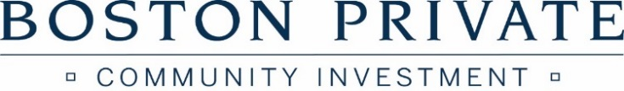

ABOUT PUBLIC COUNSEL
Public Counsel is the largest pro bono law firm in the nation. We work with major law firms and corporations to change people's futures. Our staff of 71 attorneys and 50 support staff - including five social workers - along with over 5,000 volunteer lawyers, law students and legal professionals assists over 30,000 children, youth, families, and community organizations every year. Founded in 1970, Public Counsel is the public interest law firm of the Los Angeles County and Beverly Hills Bar Associations as well as the Southern California affiliate of the Lawyers' Committee for Civil Rights Under Law.

ABOUT CAMEO
CAMEO is California’s statewide micro-business network made up of over 300 organizations, agencies, and individuals dedicated to furthering Micro-Business development in California with small and micro-business financing such as loans and credit, technical assistance and business management training. Annually, CAMEO members serve about 34,000 very small businesses with training, business and credit assistance and loans. These firms – largely start-ups with less than five employees – support or create more than 51,000 new jobs in California and generate a total of $1.5 billion in economic activity.
