Digital Marketing Toolkit
CAMEO Local Entrepreneurial Ecosystem Toolkit

CAMEO (California Association for Micro Enterprise Opportunity), the leading network of organizations dedicated to furthering small and micro business development in the state, has published new research analyzing rural economic development efforts and its recommendations for how to build stronger support for rural small businesses that drive rural economic development.

Thank you for your help to share the research and recommendations!

In this guide:
- Draft copy for CAMEO, its members and allies: Twitter and LinkedIn / Facebook
- Images

TWITTER FOR CAMEO, ITS MEMBERS & ALLIES
- New research analyzing rural economic development efforts, how to build stronger support for rural #smallbiz out today from @CAMEOMicro. http://bit.ly/LocalEntreEcosys #ruraleconomy #economicdevelopment #RuralEconDev

- More #smallbiz are closing than opening in rural areas, widening the economic gap between our country’s rural and urban areas, according to a report released today by @CAMEOMicro. http://bit.ly/LocalEntreEcosys #ruraleconomy #economicdevelopment #RuralEconDev

- Declining Entrepreneurship in Rural Areas Exacerbates Inequity Between Rural and Urban Economies. New report by @CAMEOMicro: http://bit.ly/LocalEntreEcosys #ruraleconomy #economicdevelopment #RuralEconDev

- If rural #economicdevelopment efforts support a healthy ecosystem for entrepreneurs, locally-owned #smallbiz will create #jobs, drive regional economic stability and resilience. New report by @CAMEOMicro: http://bit.ly/LocalEntreEcosys #ruraleconomy #RuralEconDev

LINKEDIN & FACEBOOK for CAMEO, ITS MEMBERS & ALLIES
Tag CAMEO on LinkedIn: https://www.linkedin.com/company/cameomicro/ (type in @CAMEO_Micro and it pops up)

Tag CAMEO on Facebook: https://www.facebook.com/MicroBizCA/ (type in @CAMEO and it pops up)

Post #1
More small businesses are closing than opening in rural areas, widening the economic gap between our country’s rural and urban areas. New research out today from @CAMEO_Microanalyzing rural economic development efforts, along with recommendations for how to build stronger support for rural small businesses. When rural economic development efforts support a healthy ecosystem for entrepreneurs, locally-owned small businesses create jobs, drive regional economic stability and bolster community resilience.

http://bit.ly/LocalEntreEcosys

#ruraleconomy #economicdevelopment #smallbiz #RuralEconDev

Post #2

“Rural policymakers need new approaches to create the conditions that support the formation of new small businesses, which are key to their communities’ economic success and sustainability,” @HeidiPickman.

New report authored by Ms. Pickman, vice president of policy and programs at @CAMEO_Micro, released today outlines strategies to develop strong local entrepreneurial ecosystems that ensure entrepreneurs have access to business and management skills training, small-dollar loans, access to markets, and policies that support entrepreneurship -- otherwise known as the five Cs: Coaching, Capital, Connections, Culture and Climate.

Steps to building robust and resilient rural entrepreneurial ecosystems include:

- Assessing a region’s existing training and capital resources
- Recruiting successful business owners to mentor start-ups
- Partnering with banks and other lenders to make affordable loan products accessible
- Ensuring broadband is strong and easily available—through subsidization if necessary

Read the full report and please share with your network and local leaders.

http://bit.ly/LocalEntreEcosys

#ruraleconomy #economicdevelopment #smallbiz #RuralEconDev

IMAGES
Download images from Drive or click on thumbnail below

TWITTER:
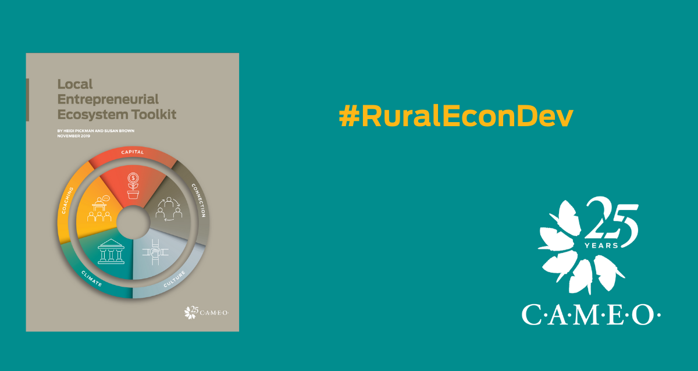

LINKEDIN:

FACEBOOK:

Press Inquiries: Caitlin McShane, caitlin@emcstrategies.com (415) 225-8855
Data Inquires: Heidi Pickman, hpickman@cameonetwork.org (415) 992-4483

About CAMEO
CAMEO is California’s statewide network made up of over 230 organizations, agencies, and individuals dedicated to furthering microbusiness development in the state. Our mission is to grow a thriving ecosystem of support for underserved entrepreneurs so that all entrepreneurs have access to the resources they need to succeed, creating family economic mobility and community prosperity.

Annually, CAMEO members serve about 34,000 very small businesses with training, business and credit assistance and loans. These firms – largely start-ups with less than five employees – support or create 51,000 new jobs in California and generate a total of $2.5 billion in economic activity. Many of the business owners that our members serve are low-to-moderate income and face challenges with access to resources. cameonetwork.org

