CAMEO 2019 Small Business Scorecard Digital Marketing Toolkit
For Member and Allies

California Association for Micro Enterprise Opportunity (CAMEO), the leading network of organizations dedicated to furthering small and micro business development in the state, has issued its inaugural Small Business Scorecard analyzing how California’s legislature scored for their leadership on small business issues during the 2019 session.

Thank you for your help to share the results! There is much to celebrate, and a few clear areas to build upon next year.

In this guide:

- Draft copy for Legislators
- Draft copy for CAMEO members and allies: Twitter and LinkedIn / Facebook
- Images

TWITTER/FACEBOOK/LINKEDIN FOR LEGISLATORS

- Thrilled to receive a XX% score in @CAMEOMicro’s 2019 #SmallBizScorecard for our work on behalf of the businesses in our district and across the state. bit.ly/CAMEO19SmBizScorecard #smallbiz

- CA-X is home to XX small businesses. In Sacramento, we passed 16 bills in #CALeg this year to support a thriving small business ecosystem in the state. Thank you, @CAMEOMicro! Check out the new 2019 #SmallBizScorecard bit.ly/CAMEO19SmBizScorecard #smallbiz

- Proud to sponsor/support AB-XX this year to [purpose of bill]. Grateful to be recognized for this work by #smallbiz champions like @CAMEOMicro in new #SmallBizScorecard: bit.ly/CAMEO19SmBizScorecard #smallbiz

Tag CAMEO on LinkedIn: https://www.linkedin.com/company/cameomicro/ (type in @CAMEO_Micro and it pops up)

Tag CAMEO on Facebook: https://www.facebook.com/MicroBizCA/ (type in @CAMEO and it pops up)

TWITTER FOR CAMEO MEMBERS & ALLIES

- #CALeg Receives High Marks in @CAMEOMicro 2019 #SmallBizScorecard. bit.ly/CAMEO19SmBizScorecard

- How did CA legislators do on #smallbiz issues this year? Overwhelming majority scored high marks. Check out @CAMEOMicro’s 2019 #SmallBizScorecard to see scores for all 119 legislators. bit.ly/CAMEO19SmBizScorecard #CALeg

- Congratulations to the 34 CA Assembly members and 21 senators earning top marks from @CAMEOMicro 2019 #SmallBizScorecard! Thx for leading on issues important to California’s small business owners. bit.ly/CAMEO19SmBizScorecard #CALeg

- #CALeg passed 16 bills this year on key issues of concern to California’s 4 million small businesses. Vote-by-vote analysis for all 119 legislators in new 2019 #SmallBizScrecard, out today via @CAMEOMicro: bit.ly/CAMEO19SmBizScorecard
- Thank you, @AsmCervantes, for your outstanding record on #smallbiz in #CALeg in 2019, and for your leadership on the California State Assembly Committee on Jobs, Economic Development, and the Economy! Check out @CAMEOMicro’s 2019 #SmallBizScorecard: bit.ly/CAMEO19SmBizScorecard
- Thank you, Senator @BenAllenCA, for your outstanding record on #smallbiz in #CALeg in 2019! Check out @CAMEOMicro’s 2019 #SmallBizScorecard: bit.ly/CAMEO19SmBizScorecard
- Thank you, @SenBobArchuleta, for your outstanding record on #smallbiz in #CALeg in 2019! Check out @CAMEOMicro’s 2019 #SmallBizScorecard: bit.ly/CAMEO19SmBizScorecard
- Thank you, @SenToniAtkins, for your outstanding record on #smallbiz in #CALeg in 2019! Check out @CAMEOMicro’s 2019 #SmallBizScorecard: bit.ly/CAMEO19SmBizScorecard
- Thank you, Senator @Jimbealljr, for your outstanding record on #smallbiz in #CALeg in 2019! Check out @CAMEOMicro’s 2019 #SmallBizScorecard: bit.ly/CAMEO19SmBizScorecard
- Thank you, Senator @SteveBradford, for your outstanding record on #smallbiz in #CALeg in 2019! Check out @CAMEOMicro’s 2019 #SmallBizScorecard: bit.ly/CAMEO19SmBizScorecard
- Thank you, @CASenCaballero, for your outstanding record on #smallbiz in #CALeg in 2019! Check out @CAMEOMicro’s 2019 #SmallBizScorecard: bit.ly/CAMEO19SmBizScorecard
- Thank you, @SenBillDodd, for your outstanding record on #smallbiz in #CALeg in 2019! Check out @CAMEOMicro’s 2019 #SmallBizScorecard: bit.ly/CAMEO19SmBizScorecard
- Thank you, @SenMariaEDurazo, for your outstanding record on #smallbiz in #CALeg in 2019! Check out @CAMEOMicro’s 2019 #SmallBizScorecard: bit.ly/CAMEO19SmBizScorecard
- Thank you, Senator @Steve_Glazer, for your outstanding record on #smallbiz in #CALeg in 2019! Check out @CAMEOMicro’s 2019 #SmallBizScorecard: bit.ly/CAMEO19SmBizScorecard
- Thank you, @SenGonzalez_33, for your outstanding record on #smallbiz in #CALeg in 2019! Check out @CAMEOMicro’s 2019 #SmallBizScorecard: bit.ly/CAMEO19SmBizScorecard
- Thank you, Senator #JerryHill, for your outstanding record on #smallbiz in #CALeg in 2019! Check out @CAMEOMicro’s 2019 #SmallBizScorecard: bit.ly/CAMEO19SmBizScorecard
- Thank you, @SenBenHueso, for your outstanding record on #smallbiz in #CALeg in 2019! Check out @CAMEOMicro’s 2019 #SmallBizScorecard: bit.ly/CAMEO19SmBizScorecard
- Thank you, @SenHannahBeth, for your outstanding record on #smallbiz in #CALeg in 2019! Check out @CAMEOMicro’s 2019 #SmallBizScorecard: bit.ly/CAMEO19SmBizScorecard
- Thank you, @SenatorLeyva, for your outstanding record on #smallbiz in #CALeg in 2019! Check out @CAMEOMicro’s 2019 #SmallBizScorecard: bit.ly/CAMEO19SmBizScorecard
- Thank you, Senator @ilike_mike McGuire, for your outstanding record on #smallbiz in #CALeg in 2019! Check out @CAMEOMicro’s 2019 #SmallBizScorecard: bit.ly/CAMEO19SmBizScorecard
- Thank you, Senator @ilike_mike McGuire, for your outstanding record on #smallbiz in #CALeg in 2019! Check out @CAMEOMicro’s 2019 #SmallBizScorecard: bit.ly/CAMEO19SmBizScorecard
- Thank you, Senator @HollyJMitchell, for your outstanding record on #smallbiz in #CALeg in 2019! Check out @CAMEOMicro’s 2019 #SmallBizScorecard: bit.ly/CAMEO19SmBizScorecard
- Thank you, Senator @billmonning, for your outstanding record on #smallbiz in #CALeg in 2019! Check out @CAMEOMicro’s 2019 #SmallBizScorecard: bit.ly/CAMEO19SmBizScorecard
- Thank you, Senator @DrPanMD, for your outstanding record on #smallbiz in #CALeg in 2019! Check out @CAMEOMicro’s 2019 #SmallBizScorecard: bit.ly/CAMEO19SmBizScorecard
- Thank you, Senator Anthony @Portantino, for your outstanding record on #smallbiz in #CALeg in 2019! Check out @CAMEOMicro’s 2019 #SmallBizScorecard: bit.ly/CAMEO19SmBizScorecard
- Thank you, @GeneralRoth, for your outstanding record on #smallbiz in #CALeg in 2019! Check out @CAMEOMicro’s 2019 #SmallBizScorecard: bit.ly/CAMEO19SmBizScorecard
- Thank you, @SenSusanRubio, for your outstanding record on #smallbiz in #CALeg in 2019! Check out @CAMEOMicro’s 2019 #SmallBizScorecard: bit.ly/CAMEO19SmBizScorecard
- Thank you, Senator @NancySkinnerCA, for your outstanding record on #smallbiz in #CALeg in 2019! Check out @CAMEOMicro’s 2019 #SmallBizScorecard: bit.ly/CAMEO19SmBizScorecard
- Thank you, Senator @HenrySternCA, for your outstanding record on #smallbiz in #CALeg in 2019! Check out @CAMEOMicro’s 2019 #SmallBizScorecard: bit.ly/CAMEO19SmBizScorecard
- Thank you, @SenatorUmberg, for your outstanding record on #smallbiz in #CALeg in 2019! Check out @CAMEOMicro’s 2019 #SmallBizScorecard: bit.ly/CAMEO19SmBizScorecard
- Thank you, Senator @BobWieckowskiCA, for your outstanding record on #smallbiz in #CALeg in 2019! Check out @CAMEOMicro’s 2019 #SmallBizScorecard: bit.ly/CAMEO19SmBizScorecard
- Thank you, Senator @Scott_Wiener, for your outstanding record on #smallbiz in #CALeg in 2019! Check out @CAMEOMicro’s 2019 #SmallBizScorecard: bit.ly/CAMEO19SmBizScorecard

…. And repeat for the Assembly.

LINKEDIN & FACEBOOK for CAMEO MEMBERS & ALLIES
Post #1
How did California legislators do on small business issues this year? The overwhelming majority scored high marks for their work to author, sponsor, and vote on the 16 bills on key issues of concern to California’s four million small businesses. More than three quarters of Assembly members and 80% of state senators earned top scores. Check out @CAMEOMicro’s 2019 #SmallBizScorecard to see scores for all 119 legislators.

“Lawmakers really stepped up this year when it came to small business, and we especially applaud the Assembly JEDE Committee for showing strong leadership by introducing some of the most important bills of the legislative session,” said CAMEO Chief Executive Officer Carolina Martinez. “However, California’s four million small business owners are grappling with rising healthcare costs and difficulty accessing capital. We need our leaders in Sacramento tackle these larger issues, beyond the 16 relatively narrow bills the Legislature passed this year.”

Votes on bills analyzed in CAMEO’s Small Business Scorecard included laws aimed at ensuring veteran-owned businesses are treated fairly in state contracts; greater lender transparency and borrower protections; and paving the way for home-based businesses to expand.

bit.ly/CAMEO19SmBizScorecard #CALeg

Post #2
How did California legislators do on small business issues this year? “Lawmakers really stepped up this year when it came to small business, and we especially applaud the Assembly JEDE Committee for showing strong leadership by introducing some of the most important bills of the legislative session.” - CAMEOMicro’s Chief Executive Officer Carolina Martinez.

The overwhelming majority of legislators scored high marks for their work to author, sponsor, and vote on the 16 bills on key issues of concern to California’s four million small businesses. More than three quarters of Assembly members and 80% of state senators earned top scores. Check out @CAMEOMicro’s 2019 #SmallBizScorecard to see scores for all 119 legislators analyzed by CAMEO, the leading network of organizations dedicated to furthering small and micro business development in the state.

bit.ly/CAMEO19SmBizScorecard #CALeg

IMAGES
Download images from Drive or click on thumbnail below

TWITTER: 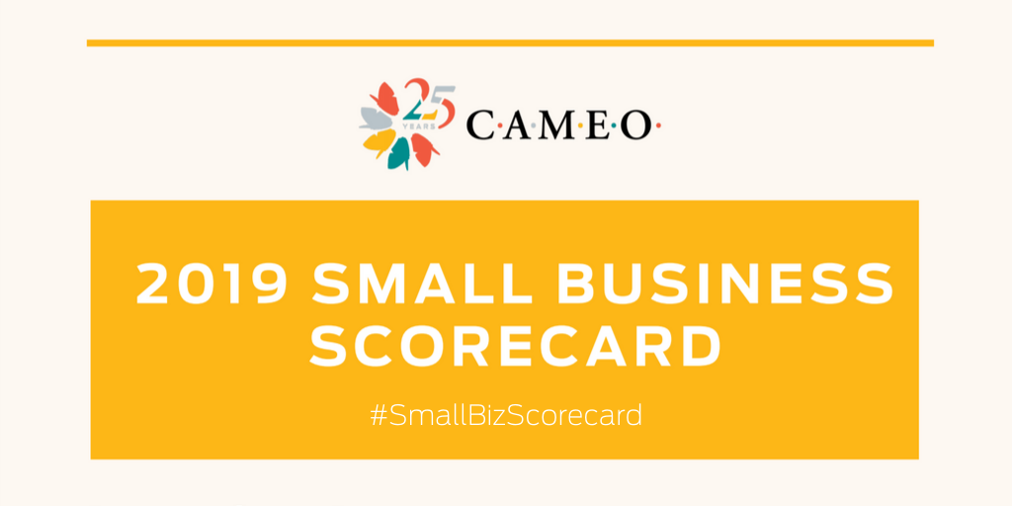
LINKEDIN: 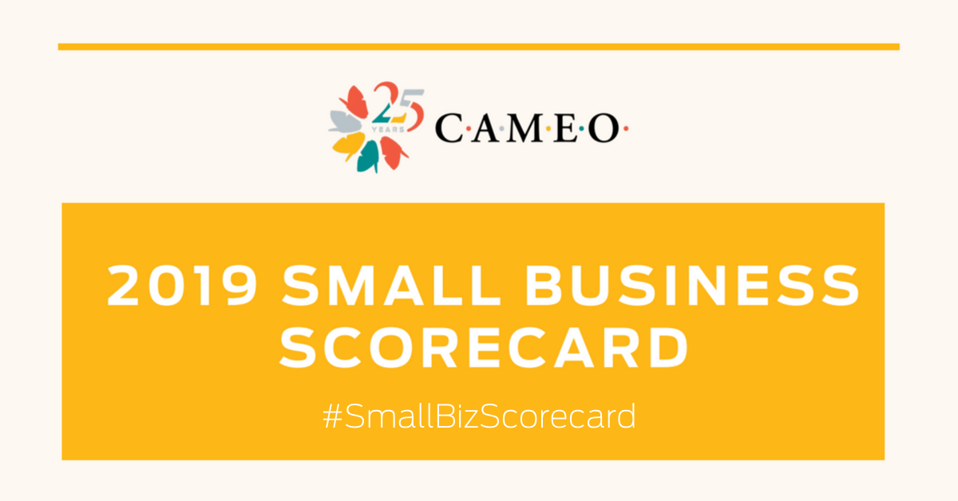
FACEBOOK: 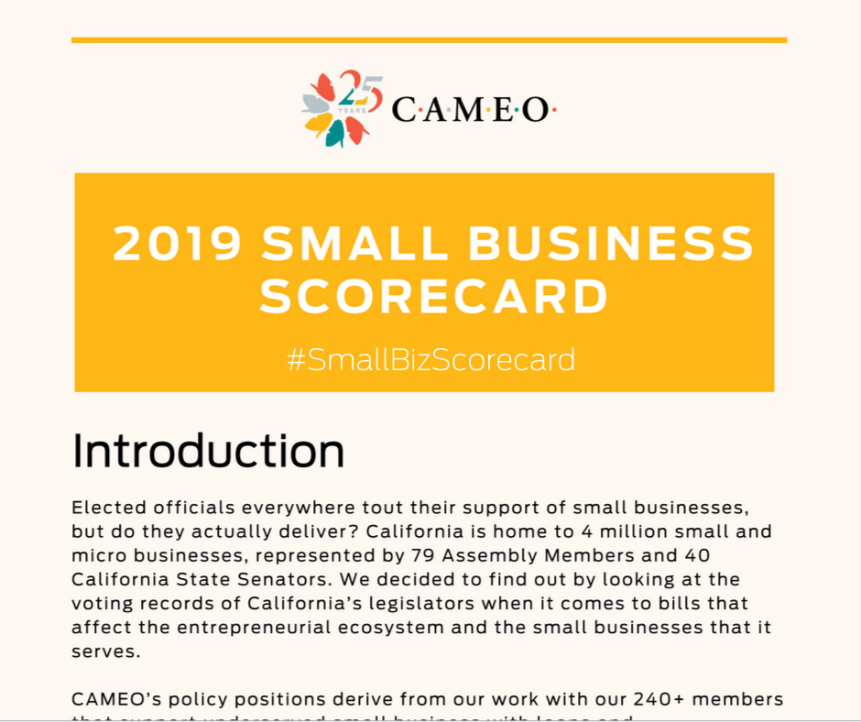

Press Inquiries: Caitlin McShane, caitlin@emcstrategies.com (415) 225-8855
Data Inquires: Heidi Pickman, hpickman@cameonetwork.org (415) 992-4483

About CAMEO
CAMEO is California’s statewide network made up of over 240 organizations, agencies, and individuals dedicated to furthering microbusiness development in the state. Our mission is to grow a thriving ecosystem of support for underserved entrepreneurs so that all entrepreneurs have access to the resources they need to succeed, creating family economic mobility and community prosperity.

Annually, CAMEO members serve about 34,000 very small businesses with training, business and credit assistance and loans. These firms – largely start-ups with less than five employees – support or create 51,000 new jobs in California and generate a total of $2.5 billion in economic activity. Many of the business owners that our members serve are low-to-moderate income and face challenges with access to resources. cameonetwork.org

